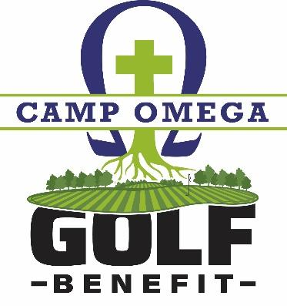

THURSDAY, AUGUST 25, 2022 - 1PM SHOTGUN
COVER LETTER
HELLO TO EVERYONE WHO HAS A HEART FOR CAMP OMEGA
Enjoy an Activity - Support an exciting Ministry

Gopher Hills GC - Cannon Falls, MN is very welcoming to be our
NEW HOST “COURSE.”
- Beautiful ClubHouse
- Professionally Personable
- Fundraising Friendly
The Camp Omega Golf Event is one of the ways we work to grow our Campership Endowment Fund. Each year $15,000-$25,000 is given out to help families in need afford to learn about Christ at Camp Omega.
Please inspire a team of four friends to participate in our 18 Hole Camp Omega Golf Benefit. They say “Enthusiasm” is contagious. So, get excited to have a little fun on our Golf day.
I am asking you to email Russ@campomega.org and tell him you are developing/encouraging a golf team to participate. Russ has details to share……….

