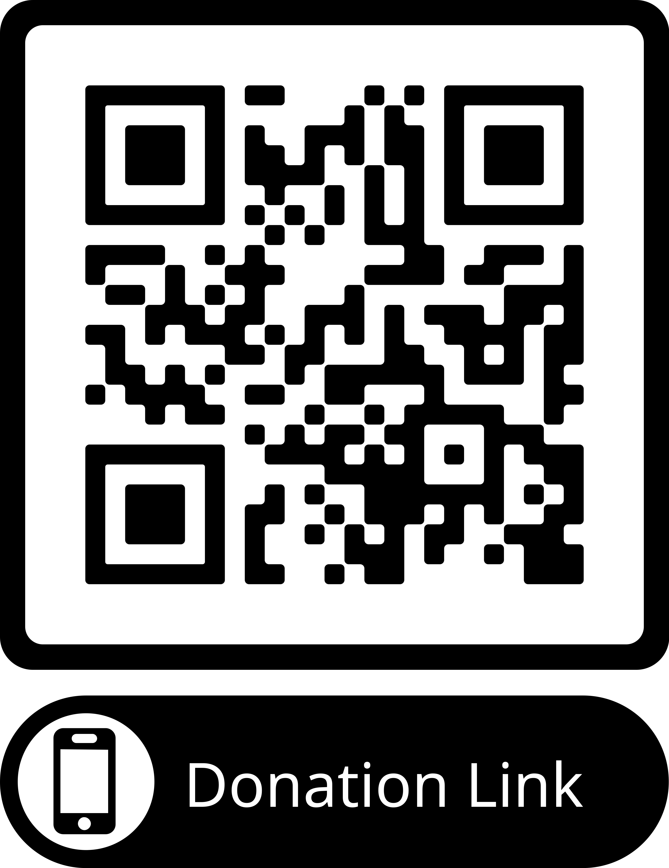
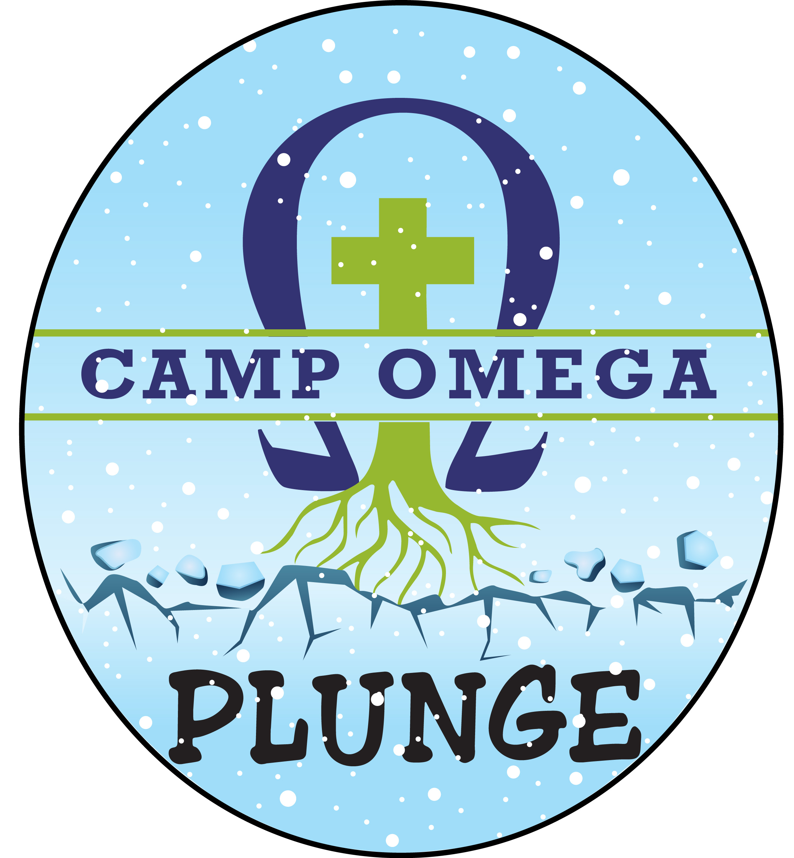
PLEDGE & DONATION SHEET

Sunday, February 25th, 2024 *Donate here using this QR code

NAME AND EMAIL | PHONE NUMBER | PLEDGE AMOUNT | PAID? | RECEIPT YES/NO
Please make checks payable to CAMP OMEGA - THANK YOU!
22750 Lind Ave, Waterville, MN 56096 Russ@campomega.org 507-384-7947

